**DEEP-DEPRESSION: Smart Diagnostic Tool for Early Identification of Depression Biomarkers**

*Our designed diagnostic tool is more efficient to identify depression biomarkers of the patients with the help of brain signals collected from the patient’s scalp surface through Electroencephalography (EEG) device.*

*Antora Dev, Dr. Nipa Roy, Dr. Md. Kafiul Islam, Dr. Chiranjeeb Biswas, Dr. Helal Uddin Ahmed, Dr. Farhana Sarker, and Dr. Khondaker Abdullah Al Mamun.*

**31st July 2022 - Dhaka, Bangladesh** – We, a multidisciplinary team from different professions as such researchers, engineers, and psychiatrists are going to design and develop a screening system to determine the depression biomarkers within human brain. Our developed supervised model can distinguish different cognitive responses between depressed and healthy brains as well as identify which part of the brain is responsible for depression by analyzing signals collected from the whole brain.

Depression is one of the most common mental illnesses, which affects our mood, and it has become a global health concern as it affects millions of lives every year. According to World Mental Health Survey, every day we have seen almost 3000 suicide cases and about 60,000 cases have been found who may attempt to end their lives1. In addition, the statistical ratio of suicide cases due to depression caused by the recent pandemic crisis is growing at an alarming rate. Till now, for diagnostic purposes, psychiatrists are choosing different clinical questionnaire-based assessments where the answers provided by the patient and observing the patient’s behavior to identify the depression2. However, this process takes longer sessions as well as continuous monitoring3.

We know that human brain cannot lie to us. So, along with the conventional techniques, we can analyze the depression biomarkers through analyzing brain signals. Moreover, we have a high density-based EEG device, through which we can have whole brain recording that helps us to determine responsible brain regions affected by depression. To our best knowledge, this device is the first of its kind in Bangladesh. Our designed system is more time-efficient, patient-friendly, and affordable diagnostic tool for clinical interventions.

**Our respective team leader, research and scientist Professor Khondaker Abdullah Al Mamun once mentioned that \*\*\*\***

To our best knowledge, there are no specific identification tools for depression biomarkers. As we know that depression has higher neurological impacts, Brain-Computer Interface (BCI) technology can be used to develop a better diagnostic tool as a ground-breaking intervention.

Our prior customers are psychiatrists, psychologists, psychological service providers, and therapists. The customers will get to have a primary knowledge of our service from our website. To get our service, customers need to verbally communicate with us over phone from contact details mentioned on our website. Our executive will demonstrate the whole process of determining depression by analyzing the patient’s brain signals. Not only to identify the depressed patients but also can help to evaluate the clinical questionnaire assessments as well as analyze the effectiveness of neurological treatments.

We have discussed with the professionals and two psychological farms where they have used our model. They all agreed with us that our designed depression diagnostic tool is a useful intervention that can help to have better screening. We have talked with the patients about their experience who have taken our service from those psychological farms. One patient wrote to us about their experience “Until diagnosing my mental state through this device, I couldn’t believe that this device could get through my mind and let me help to overcome my bad times. I have taken this service for 6 months under Psychiatrist Dr. Nurrrunahar to check my mental state. This device is so comfortable to wear and is helping me to recover faster.”

To know more in details about our project, please click on following link[1]:

**FAQ:**

1. **What is BCI technology and EEG device?**

Answer: The abbreviation of BCI is Brain-Computer Interface. It allows the human to communicate directly with the external device by commanding through the brain signal collecting with a device called Electroencephalography (EEG).

1. **Who are your consumers and who can get help through this system?**

Answer: Mostly psychiatrists, psychologists, psychological service providers and therapists. However, they need to show their proper license of having psychological and mental health knowledge. Through this system, anyone having depression can be screened. Along with it, professionals may also check patient’s improvement by using our supervised model.

1. **How do I find this?**

Answer: Our designed model will come with the compact EEG device along with its accessories for recording brain signal. The accessories can be purchased from our website. You can contact through our website.

1. **How do I complete the task, if I want can I return the device?**

Answer: There will a guideline or an instruction manual book along with our system. Both use and cleaning processes have been mentioned step by step in the manual book.

1. **How can I get help, if I have a problem?**

Answer: You can purchase the model along with its manual. Even if you face problem with the manual, you can contact through our website[2] or email us at following email address[3].

1. **Can I use this in every country?**

Answer: Yes, we can deliver our designed model to every country.

1. **Does it affect to human body?**

Answer: There will be no significant health hazard while screening through our model. However, we need the brain signals from the patient which will be collected from the patient’s scalp surface through EEG device. This is a similar process like ECG device, where ECG device records heart rate and rhythms.

1. **What data are you collecting from the patients and what will it be used for?**

Answer: For screening through our model, we need brain signal from the scalp surface from some specific brain regions mentioned in the manual book. This will allow us to determine whether the patient has depression or not.

1. **How are you protecting patient’s data and his privacy when he uses this product?**

Answer: The patient’s data will be protecting and will be analyzed only by his professionals. Even if we, the researchers or our development team want to use it as research purpose, we will take consents from those patients before using this.

1. **Does it help to recover from depression?**

Answer: Yes, as we know verbal speech cannot all-time represent the current state of one’s mind. In that case, our model will help to check the feasibility of treatments prescribed by the professionals to recover from depression.

1. **Do I need any application or software to operate your developed model?**

Answer: Yes, the model will come an analyzer with a license for offline signal processing purpose as well as direct interface with MATLAB.

1. **If there are changes to how it works, how will I find out?**

Answer: Please follow our website or our following Facebook page[4] to keep updated about our products.

**VIZUALIZATION**

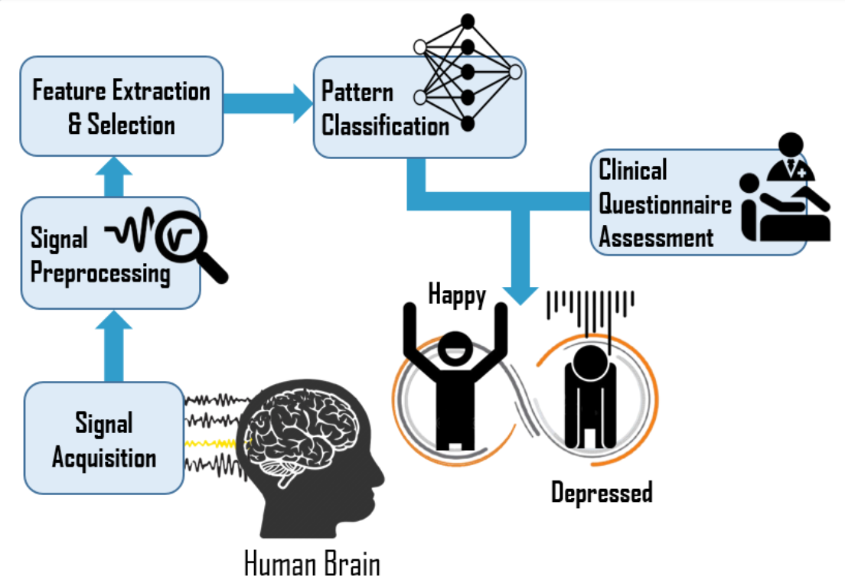

**APPENDIX**

**CONTRIBUIONS**

We are grateful to Bangladesh High-tech Park Authority, ICT Division generously established BCI facilities in AIMS Lab at United International University with a high density-based EEG device, through which we are able to have whole brain recording.

**ABBREVIATIONS**

EEG = Electroencephalography

BCI = Brain-Computer Interface

**REFERENCES**

1. Enhanced Reader.

2. Assessments and evaluations for mental illness treatment - Better Health Channel. https://www.betterhealth.vic.gov.au/health/servicesandsupport/assessments-and-evaluations-for-mental-illness-treatment. Accessed September 30, 2021.

3. Rolstad S, Adler J, Rydén A. Response Burden and Questionnaire Length: Is Shorter Better? A Review and Meta-analysis. *Value Heal*. 2011;14(8):1101-1108. doi:10.1016/J.JVAL.2011.06.003

1. Website link: <https://aimsl.uiu.ac.bd/#/projects/DEEP-DEPRESSION>
2. Contact Details: <https://aimsl.uiu.ac.bd/#/contact>
3. Email Address: [aimsl@uiu.ac.bd](mailto:aimsl@uiu.ac.bd)
4. <https://www.facebook.com/aimslab/>